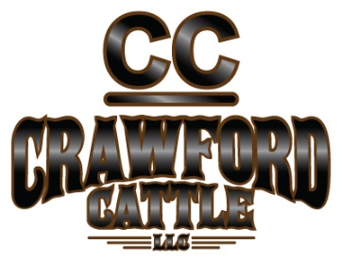
Open Job Announcement:
Mechanic/Shop Manager
Location:
Grayson Ranch
Paradise Valley, Nevada
Position Overview:
Crawford Cattle is looking for an honest, motivated and dependable mechanic/shop manger to be stationed at the ranch headquarters in Paradise Valley (30 minutes north of Winnemucca). The mechanic will be responsible for the maintenance and repairs of ranch vehicles and equipment as well as some basic fabricating. The ranch has a large heated shop that most of the work will be done in but there will be some field work. This position will have a great deal of autonomy and candidates must be self-motivated as management will often not be around the ranch. Candidates must be extremely organized and tidy. In addition, applicants must be willing to help develop shop systems such as inventory management and work order tracking. This position will require the ability to order parts and be working on several projects that are at various stages of completion. Good communication skills are a must. Preference will be given to those with computer skills such as Microsoft Excel. We are seeking an individual that is ambitious and wants to help develop a professional level shop. This is a family friendly position.
Skills/ Education Required:
To be considered for this position the candidate must have a skill set including:
- Ability to diagnose and repair various automobiles- mostly pickups.
- Ability to diagnose and repair tractor trailers- cattle wagons, flatbeds, dump truck, etc.
- Ability to diagnose and repair ranch equipment- John Deere tractors, New Holland tractors, Kerby bale choppers and feed trucks, Case loader, etc.
- Ability to diagnose and repair small equipment- generators, welders, mowers, 4-wheelers, etc.
- Must be able to weld. Tire skills a plus.
- Must be able to communicate effectively and in a timely manner.
- Time management skills and ability to prioritize and get work done within appropriate time frames including the ability to work without direct supervision.
Other Qualifications Required:
- Valid Driver License.
- At least a High School Diploma or equivalent, preference will be given to candidates with a trade school certificate, Associate’s Degree or Bachelor’s degree.
- Speaking Spanish is not required but will give an applicant a competitive advantage.
Benefits:
Compensation is competitive and will be commensurate with the successful candidate’s education and experience including opportunities for annual performance bonuses and raises. Crawford Cattle offers a monthly stipend to put towards health insurance for you and your family.
About Us:
Crawford Cattle LLC is a growing commercial cattle company that operates four expansive cattle ranches throughout Northern Nevada. To date, Crawford Cattle runs approximately 6,000 mother cows on over 1 milllion acres of both private and federal grazing lands.
To Apply:
Send cover letter and resume (with references) to Shane Hall, by email, ccbarcattle@gmail.com, or through the US Postal Service at 146 Grayson Ranch Road, Winnemucca, NV 89445. For more information contact General Management Steve Hall (775-304-1365) or Shane Hall (775-304-8802).

